##### INDUSTRIAL TRAININING

##### (PHASE-I)

**Undergone at**

**OneMobikwik Solutions Pvt Ltd**

***Gurugram - Haryana***

##### A PRESENTATION REPORT

On

Testing and Automation

###### ***Submitted by***

##### SATYAM PUNIYA

RA1511008010409

***in partial fulfillment for the award of the degree***

***of***

##### BACHELOR OF TECHNOLOGY

IN

INFORMATION TECHNOLOGY



SEPTEMBER 2017

**BONAFIDE CERTIFICATE**

Certified that the report on ‘TESTING AND AUTOMATION’ is a proof of successful completion of Industrial Training Phase–I programme undergone by SATYAM PUNIYA (RA1511008010409) in the company ONE MOBIKWIK SYSTEMS PVT LTD located in GURUGRAM , HARYANA. During the period 14 JUNE, 2017 to 14 JULY, 2017.

**Date Signature of Staff incharge**

**DECLARATION**

I hereby declare that the presentation report submitted titled “TESTING AND AUTOMATION”, is a record of my industrial training program which I had undergone in the company ONE MOBIKWIK SYSTEMS PVT LTD during the end of the fourth semester between the period 14th JUNE, 2017 to 14th JULY, 2017.

Date : 21/09/2017

Name : SATYAM PUNIYA

Register Number : RA1511008010409

Signature of Student

**Rubrics for Evaluation**

|  |  |  |  |
| --- | --- | --- | --- |
| **Serial No.** | **Marks Split up** | **Maximum marks** | **Marks Obtained** |
| 1 | Report Preparation | 50 |  |
| 2 | Presentation | 25 |  |
| 3 | Quiz and Viva | 25 |  |
|  | Total | 100 |  |

**Signature of Staff**

**Table of Contents**

|  |  |  |
| --- | --- | --- |
| **SERIAL NO.** | **TOPIC** | **PAGE NO.** |
| 1 | Industrial Training Certificate | 6 |
| 2 | About the Company | 7 |
| 3 | Technical Work / Training | 9 |
| 4 | Conclusion | 22 |

**ABOUT THE COMPANY**

### WHAT IS MOBIKWIK?

MobiKwik is available for use at more than 2,50,000 online and offline avenues. Get kwik, hassle-free payments that are super-secure! The wallet app is used to browse the biggest online, retail and fashion stores.

MobiKwik is super-safe. Each and every penny stored in your wallet is well accounted for. You can also use the extra in-app security settings available on all mobile platforms MobiKwik is operational on. These are Android, Windows and iOS. All services of MobiKwik are also available via a desktop site and a mobile site.

BookMyShow, Café Coffee Day, Domino's Pizza, Sagar Ratna, Big Bazaar, Pizza Hut, TastyKhana, JustEat, PVR, eBay, Jabong, Snapdeal, Shopclues, HomeShop18, Naaptol, Pepperfry, Fashionara, FashionAndYou, MakeMyTrip, Ferns N Petals, are just some of the many brands associated with MobiKwik.

MobiKwik received the coveted PrePaid Payment Instrument license from the Reserve Bank of India on 18 July, 2013.

### WHY USE MOBIKWIK:

**Safe & Secure Payments:** There is no need to share your valuable payment details at every other website you shop at. Just use MobiKwik to shop from anywhere you want.

**Fastest Checkout:**With the one-click process, MobiKwik has become the quickest checkout option when you are shopping online.

**Multiple Payments:**To store money once and make multiple transactions with MobiKwik.

**Discounts & Offers:** To get exclusive discounts & cashbacks at partner websites when you pay with your MobiKwik wallet.

**HISTORY**

MobiKwik was founded in 2009 by husband and wife team Bipin Preet Singh and Upasana Taku.Singh, a 2002 graduate of [IIT Delhi](https://en.wikipedia.org/wiki/IIT_Delhi), saw an opportunity to improve mobile recharge options. He seeded the company with USD$250 thousand of his own money, developed the website and payment options, and rented office space in Dwarka, Delhi. The initial service was a website with a closed wallet facility, but over the years, MobiKwik extended their service to mobile apps.The company initially partnered with online merchants to make their wallet available as a payment option on [e-commerce](https://en.wikipedia.org/wiki/E-commerce) sites.

**OVERVIEW**

MobiKwik launched an [e-wallet](https://en.wikipedia.org/wiki/Digital_wallet) system in 2012 that enabled users to deposit money online to use for bill payments and other features.In September 2014, Express Computer reported how MobiKwik was partnering with [GoDaddy](https://en.wikipedia.org/wiki/GoDaddy) and other international companies to help them comply with Indian payment regulations.In June 2017, 80 percent of India's mobile wallet transactions market was performed by [Paytm](https://en.wikipedia.org/wiki/Paytm), [ITZCash](https://en.wikipedia.org/w/index.php?title=ITZCash&action=edit&redlink=1) and Mobikwik.In March 2017, MobiKwik's largest competitor was [Paytm](https://en.wikipedia.org/wiki/Paytm).

In April 2015, MobiKwik was used by 15 million users and claimed to be adding one million new customers every month, according to Forbes India Magazine.In a partnership with CashCare, MobiKwik began providing small loans between 500–2,500 [Indian rupees](https://en.wikipedia.org/wiki/Indian_rupee) to customers in May 2016. In November 2016, MobiKwik had over 1.5 million merchants using its service and 55 million users.

Following the [2016 Indian banknote demonetisation](https://en.wikipedia.org/wiki/2016_Indian_banknote_demonetisation) in November 2016, MobiKwik realized a 400% increase in financial transactions using the service by late December, 2016.

In February 2017, the company announced plans to invest approximately USD$45 million to expand its user base from 50 million to 150 million users in 2017.

**WEBSITE -** [www.mobikwik.com](http://www.mobikwik.com)

**TECHNICAL WORK / TRAINING**

The focus of the training was on learning the fundamentals of Website Testing and Automation. In the training period, we were taught both the practical and conceptual skills that build the foundation for understanding basic Testing through software like Selenium,Postman etc. The starting phase of my training covered the following topics :

* Postman
* Basics of DBMS
* MongoDB Basics
* Advanced Java to access WebElements
* Website Automation
* WebDriver in java
* Selenium in Java
* Parsing Excel file in a java program
* Selenium tool with Firefox
* TestNG Framework
* Dependencies in Maven

**PROJECT OVERVIEW :**

The conclusion phase of my training was more interesting and thrilling as I had to complete a project for the company in which I came to learn more in detail and depth about how it all works in a professional environment. I got to know how to access WebElements using Selenium Webridver in JAVA which included locating the WebElement and also assigning of WebDriver with the name or the xpath of the WebElement.

**Test Automation**

* Test automation is the use of software
  + To set test preconditions.
  + To control the execution of tests.
  + To compare the actual outcomes to predicted outcomes.
  + To report the Execution Status.
* Commonly, test automation involves automating a manual process already in place that uses a formalized testing process.

**Selenium**

* Selenium is a robust set of tools that supports rapid development of test automation for web-based applications.
* Selenium provides a rich set of testing functions specifically geared to the needs of testing of a web application.
* Selenium operations are highly flexible, allowing many options for locating UI elements and comparing expected test results against actual application behavior.

**Selenium Features**

* Supports Cross Browser Testing. The Selenium tests can be run on multiple browsers.
* Allows scripting in several languages like Java, C#, PHP and Python.
* Assertion statements provide an efficient way of comparing expected and actual results.
* Inbuilt reporting mechanism.

SELENIUM IDE USER INTERFACE :

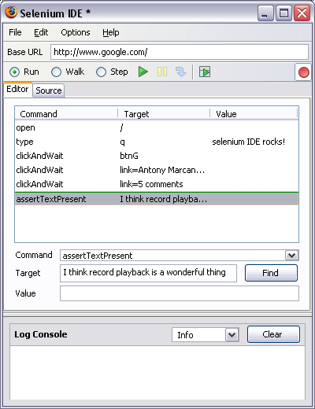

**General Selenium Commands :**

* clicking a link - *click* or *clickAndWait* commands
* entering values - *type* command
* selecting options from a drop-down listbox - *select* command
* clicking checkboxes or radio buttons - *click* command

**Creating a Test Suite :**

* In the Selenium IDE you can create any number of test cases and save them as test suite.
* To Run the test Suite click on the “Play entire test suite” button as shown below.

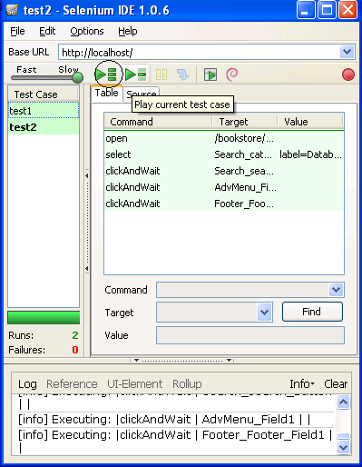

**Playing The test Suite with Test Runner :**

* Test Runner allows you to run the test case in a browser loaded with the Selenium-Core TestRunner.
* Test runner is invoked by clicking the below Shown button in the IDE

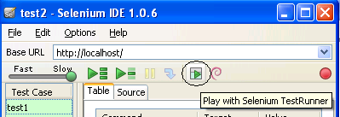

* On Clicking the Test Runner Button you will the window as seen in the next slide.

**Running Options :**

* Run a Test Case
* Run a Test Suite
* Stop and Start
* Stop in the Middle

**Assertions :**

* Assertions are same as Verifications. The only difference is, if the assertions fail the script will abort. But the script will continue run in case a verification point fails.
* The steps for inserting the assertions is same as that of verification point.
* While recording Right Click 🡪 Show all commands 🡪 select an assertion.

**Assertion Statements :**

* assertTextPresent :

This will assert if the text is present in the page.

* assertText :

This will assert if a particular element is having the particular text.

* assertTitle :

This will assert if the page is having a proper title.

* assertValue :

This will assert if a Text box or check box has a particular value.

* assertElementPresent :

This will assert if a particular UI Element is present in the page.

**Running a Selenese Test on Different Browsers :**

* Record a test case using selenium IDE and save it as “Test1.html” (say).
* Record another test case using selenium IDE and save its as “Test3.html” (say).
* In this way you can record any number of test case using selenium IDE and save them as <filename>.html
* Then Create a New Test Suite using the File Menu. See the Image Below.

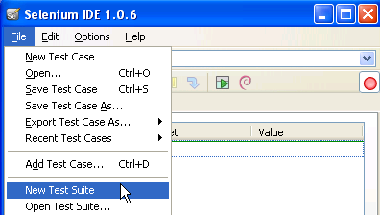

**Selenium Test Case Development Using Java :**

Required Software :

* Selenium RC Server jar , Selenium Java Client Driver jar , JDK 1.6 +, Eclipse (or any other IDE), Junit jar and testng jar.
* For building the frame work we require continuous build integration tools like Ant, Maven or cruise control.

**Create a Project In eclipse :**

* File 🡪 New 🡪 Java Project .

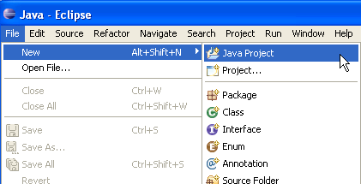

* Specify the project name and click finish :

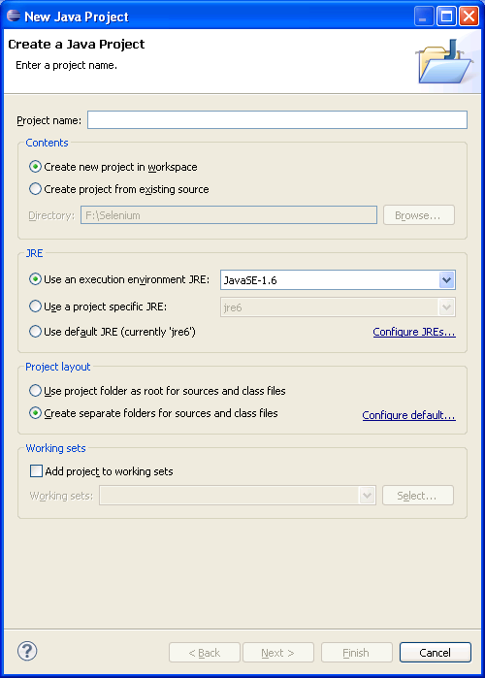

* Right Click on the Project
* Select Build Path 🡪 Configure Build path
* On the next window click on the libraries tab and click on the add jars tab.

**Adding the Jar files to the class path :**

* Inside the lib folder place the following jar files.
* junit-4.8.1.jar
* selenium-java-client-driver.jar
* selenium-server.jar
* testng-5.12.jars

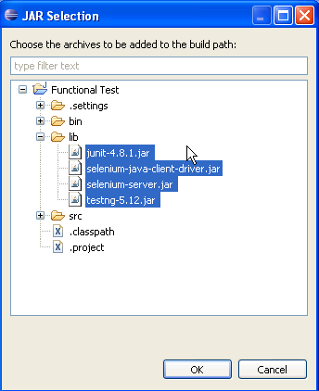

**Creating the test script inside the class file :**

* Copy the code that was formatted in the selenium IDE and paste it in the Eclipse IDE script template.
* Make sure the class name that you created and the class name in the script are same
* Make sure that you have add the methods setUp and teardown.

**Running the test through Eclipse :**

* Start the Selenium Server
* For this open the command prompt and go to the folder where the selenium server is present.
* Run the command “java - jar selenium.jar”
* The Selenium server will start running.!

**FINAL PROJECT :**

In my final project I was told to automate the MobiKwik Hotels website as I was a part of the Hotels team. I had to make a program in java that would automate the whole website using Selenium WebDriver which could be firefoxdriver or chromedriver. I personally learnt a lot about automation , which includes how to inspect any WebElement and find out its Xpath or a designated id by which the WebElement could be easily found out.

I was personally guided by Mr.Saarthak Vats (Product Manager) OneMobiKwik Solutions Pvt Ltd. The overall experience of sitting and working in an office was absolutely fantastic. I met some wonderful people there many of which usually guided me so I can thrive in my future.

It was an experience of a lifetime and I would personally thank everybody who was a part of it.I will never forget an experience like this.

THE GOOGLE DRIVE LINK FOR THE PROJECT :

<https://drive.google.com/open?id=0B-TWUQxHtZiqODB1S1FZNEREUzA>

**CONCLUSION**

The course was mainly for software testing professionals and anyone who is interested in planning and performing web application performance tests. The main goal of the training program was to define the process, tools, issues and challenges for the performance testing in a variety of web environments. The course has two levels. Fundamental Level, which addresses for professionals requiring to have a basic understanding of performance testing. However, they can further move on to Advance Level in order to learn the in-depth knowledge.

#### **Training Objective**

The following were the traits that were taught and accomplished in the entire training period:

* Examine performance requirements and ensure that the requirements are realistic and achievable.
* Specify what types of performance tests are required and create tests, test cases and test scripts.
* Communicate adequately with appropriate technical personnel to ensure that the correct test environments are set up
* Understand the capabilities of performance testing tools and make a significant contribution to tool selection.
* Execute performance tests and analyze the results
* Make a contribution to diagnosing performance problems.
* Understand how to test a site’s reliability and scalability prior to release.